

**BAG&BAG**



Student Name: ***Fakiha Jalal Uddin***

Student Name: ***Hifza Siddiqui***

Student Name: ***Muneeza Abdul Nabi***

Student Name: ***Chandni***

Faculty: ***Miss Sahia***



**APTECH COMPUTER EDUCATION**

**METRO**

**Contents**

**Project Certification 2**

**Introduction 3**

**Problem Statement 5**

**Hardware / Software Requirements: 6**

**Screenshots 7**

# **Project Certification**

This is to certify that

***Fakiha Jalal Uddin (1389187)***

***Muneeza Abdul Nabi(1388496)***

***Hifza Khalid(1373741)***

***Chandni (1372317)***

has successfully designed & developed

**Bags&Bags**

Date of Submission: **15 NOVEMBER 2022**



**Introduction**

The thirst for learning, upgrading technical skills and applying the concepts in real life environment at a fast pace is what the industry demands from IT professionals today. However busy work schedules, far-flung locations, unavailability of convenient time-slots pose as major barriers when it comes to applying the concepts into realism. And hence the need to look out for alternative means of implementation in the form of laddered approach.

The above truly pose as constraints especially for our students too! With their busy schedules, it is indeed difficult for our students to keep up with the genuine and constant need for integrated application which can be seen live especially so in the field of IT education where technology can change on the spur of a moment. *Well, technology does come to our rescue at such times!!*

Keeping the above in mind and in tune with our constant endeavour to use Technology in our training model, we at Aptech have thought of revolutionizing the way our students learn and implement the concepts using tools themselves by providing a *live and synchronous eProject learning environment!*

**So what is this eProject?**

eProject is a step-by-step learning environment that closely simulates the classroom and Lab based learning environment into actual implementation. It is a project implementation at your fingertips!! An electronic, live juncture on the machine that allows you to

* Practice step by step i.e. laddered approach.
* Build a larger more robust application.
* Usage of certain utilities in applications designed by user.
* Single program to unified code leading to a complete application.
* Learn implementation of concepts in a phased manner.
* Enhance skills and add value.
* Work on real life projects.
* Give a real life scenario and help to create applications more complicated and useful.
* Mentoring through email support.

The students at the centre are expected to complete this eProject and send complete project along with the documentation to eProjects Team

Looking forward to a positive response from your end!!

**Objectives of the project**

The Objective of this program is to give a sample project to work on real life projects. These applications help you build a larger more robust application.

The objective is not to teach you JavaScript/Dreamweaver but to provide you with a real life scenario and help you create basic applications using the tools.

You can revise the chapters before you start with the project.

This project is meant for students who have completed the module of ***Dreamweaver***. These programs should be done in the Lab sessions with assistance of the faculty if required.

It is very essential that a student has a clear understanding of the subject. Students should go through the project and solve the assignments as per requirements given.

Kindly get back to eProjects Team in case of any doubts regarding the application or its objectives.

**Problem Statement**

BagBag is an online store for various types of Bags. They have collection of bags. Now they want to revamp their website with all the products listed on the website. Consumers should find it easy to view various products and decide upon purchasing the right product to meet their requirements.

A website needs to be designed to display various bags available with the store. Details of locations, feedback must be included.

**Requirement Specification:**

The Web site is to be created based on the following requirements.

1. The Home Page should be created making use of Sections with a suitable logo, the header section can be added which will show images of various Bags.
2. The site must contain the links to navigate through various types of Bags, BackPacks etc.
3. Site should have different section for Men and Women and bags should be placed accordingly.
4. Links of bags must be categorized like (Bags, Sling Bags, BackPacks etc.)
5. Specification and Pricing of Bags should be added along with the images.
6. Website should provide section for various brands offered in the store.
7. Gallery section should be added for viewing different images.
8. Feedback must be allowed to enter by the viewer
9. Site map, Gallery, about us, Queries link, Contact us link must be added.
10. The complete description must be allowed to get download as pdf or doc file.
11. The advertise section with various facilities provided should be mentioned.

**Hardware/ Software Requirements**

**Hardware**

* A minimum computer system that will help you access all the tools in the courses is a Pentium 166 or better
* 64 Megabytes of RAM or better

**Software**

* Notepad/HTML editor
* Dreamweaver
* IE 5.0/ Netscape 6.0

**Screenshot**

***HOME***

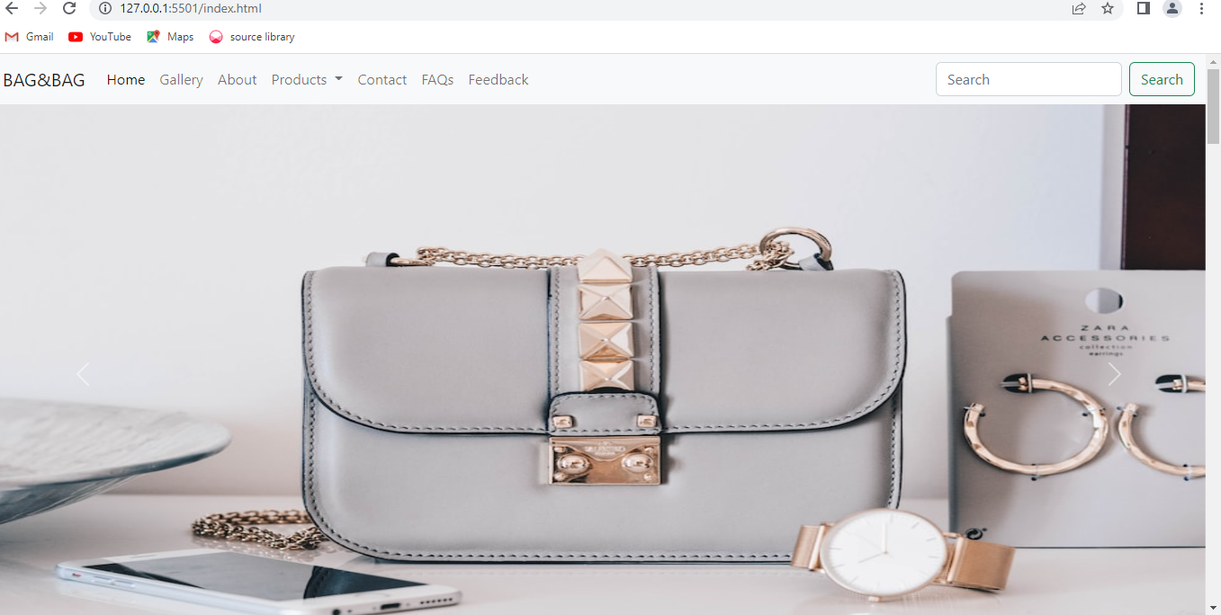

***GALLERY***

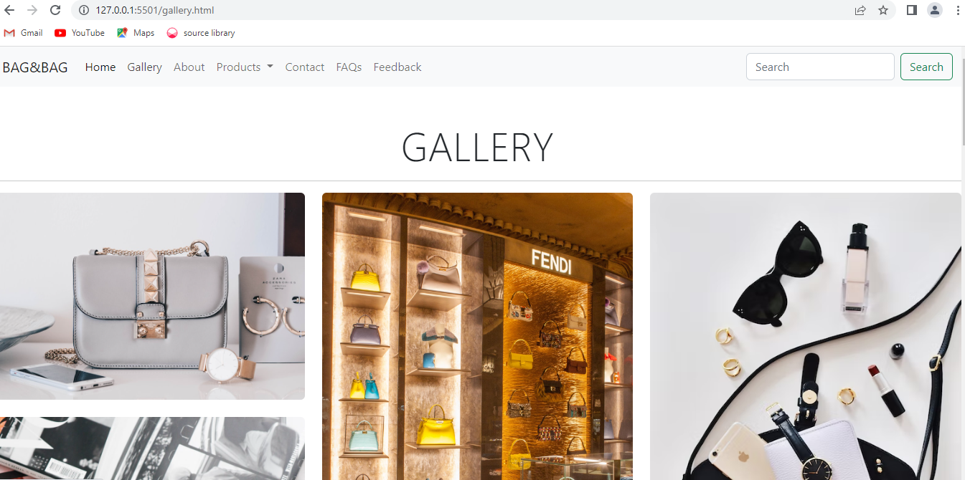

***ABOUT US***

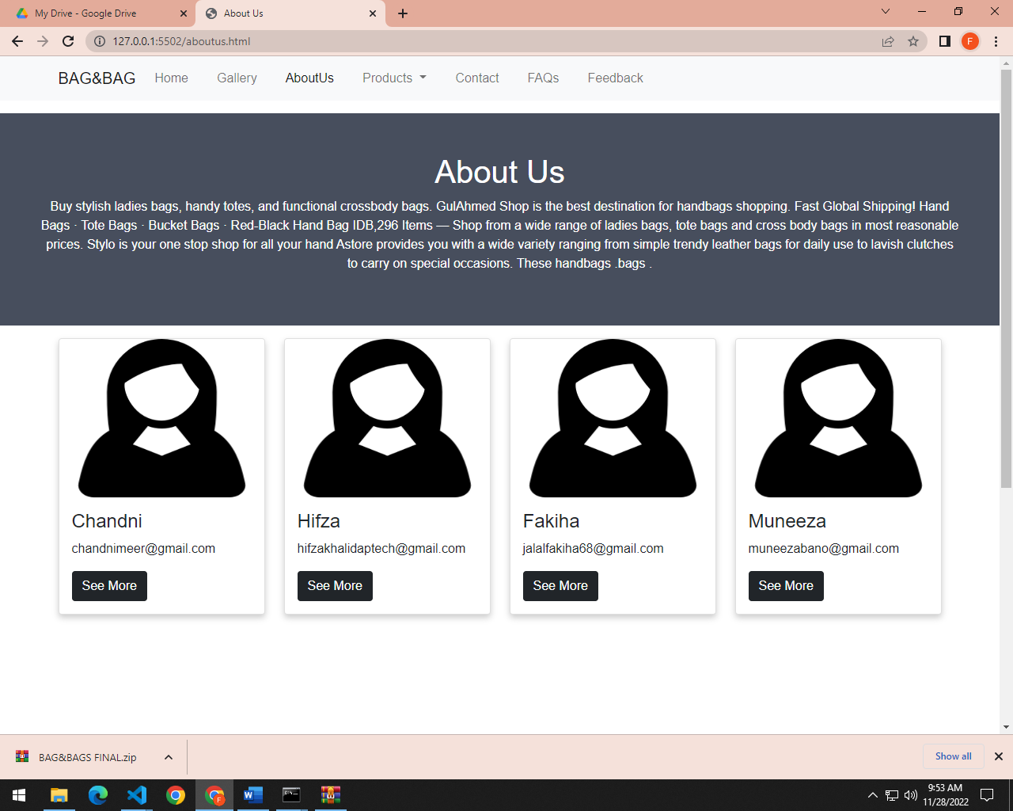

***ALL PRODUCTS***

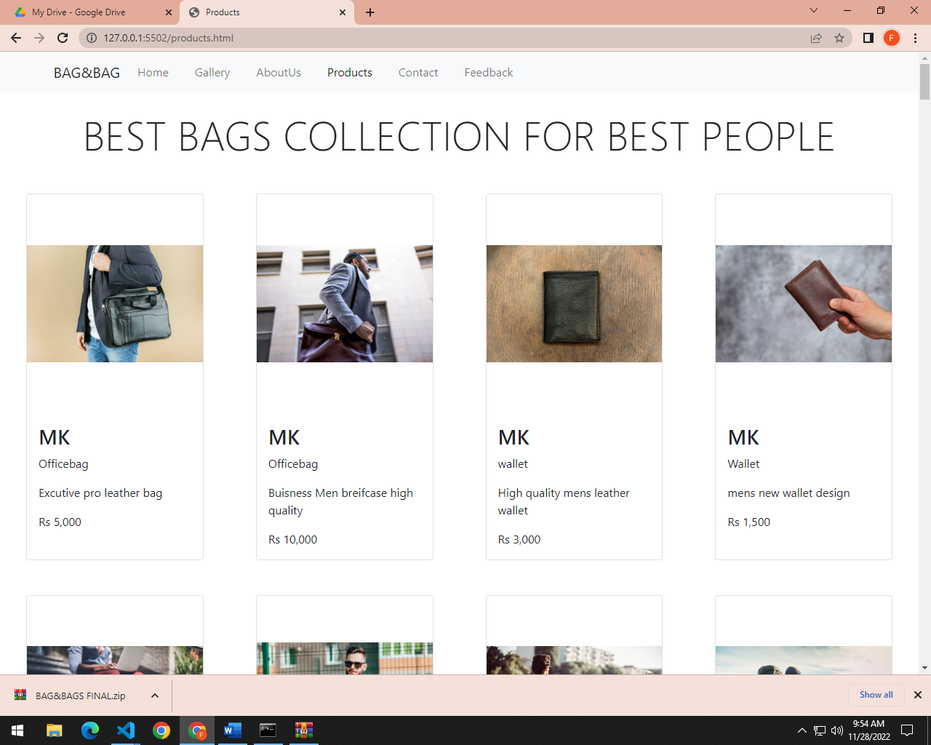

***MEN***

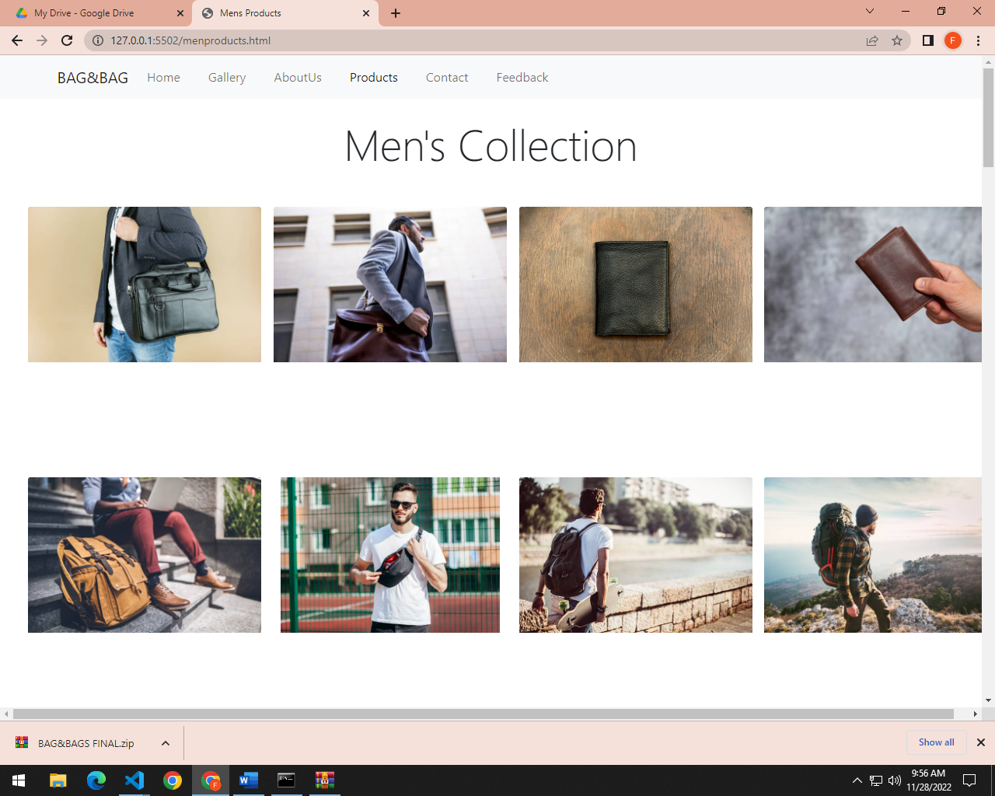

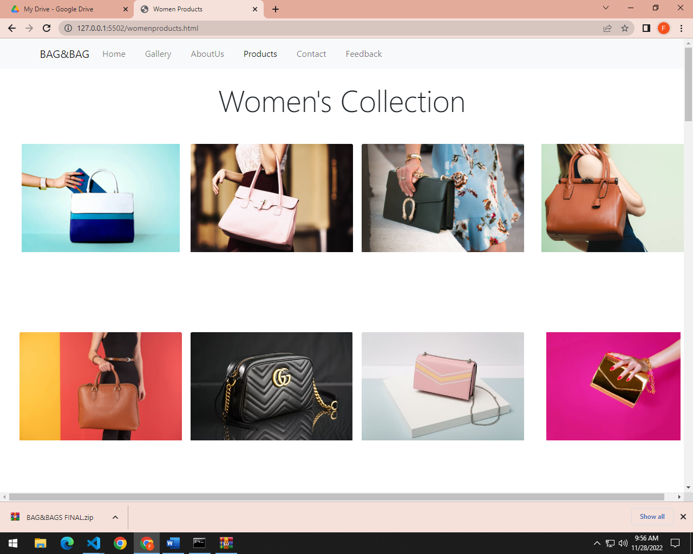***WOMEN***

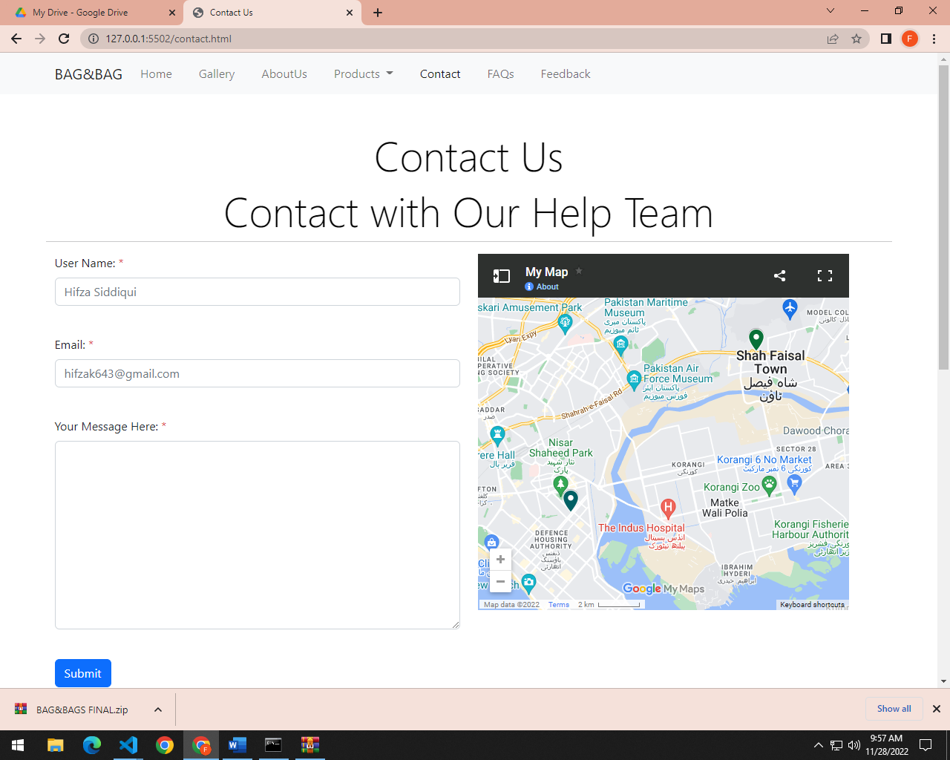***CONTACT US***

***FAQs***

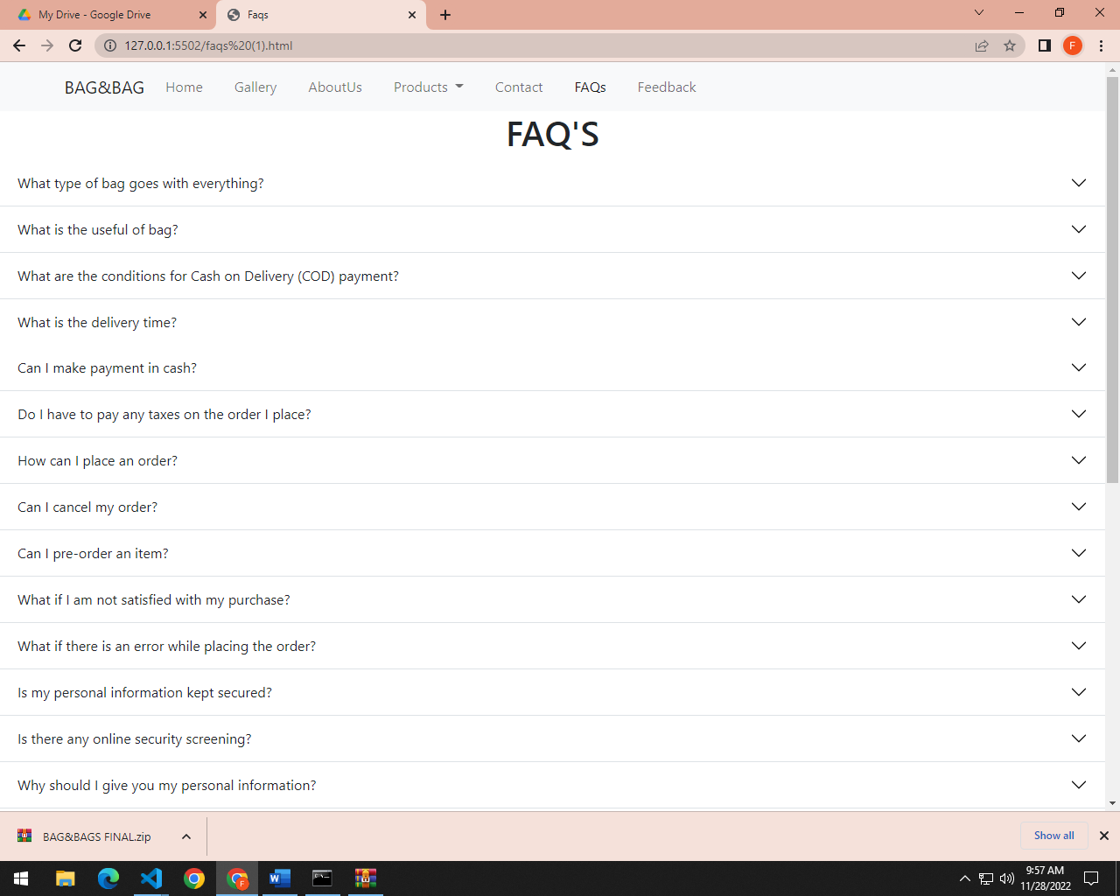

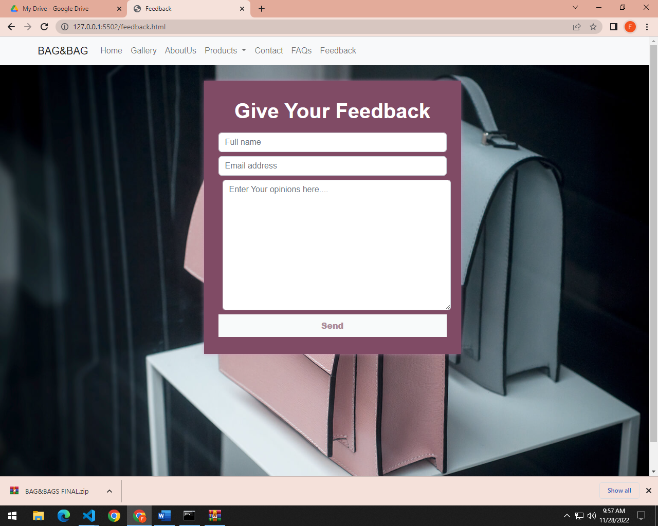

***feedback***

***DESCRIPTION***

